Use Case 01:

* Screenshot of Application Before Using and with Text Written

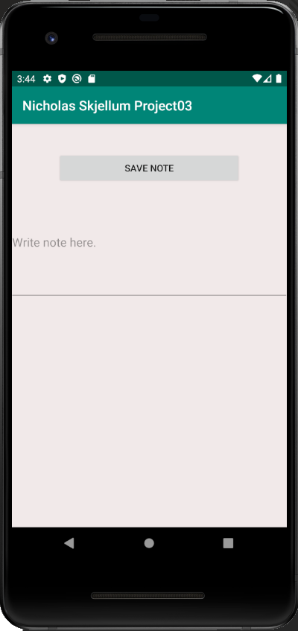 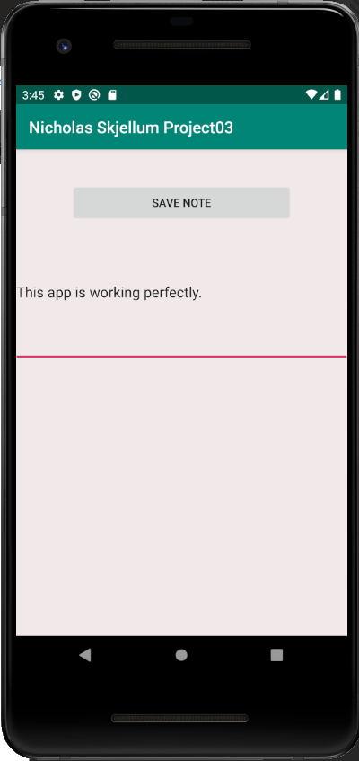

* Screenshot of Application with Note Saved and with Multiple Notes Saved + With a visible edit of a saved note.
* 